- https://page.hockeycanada.ca/page/hc/ohf/ontario-minor-hockey-association/region-6-j/clarington
- Click on View Online Stores
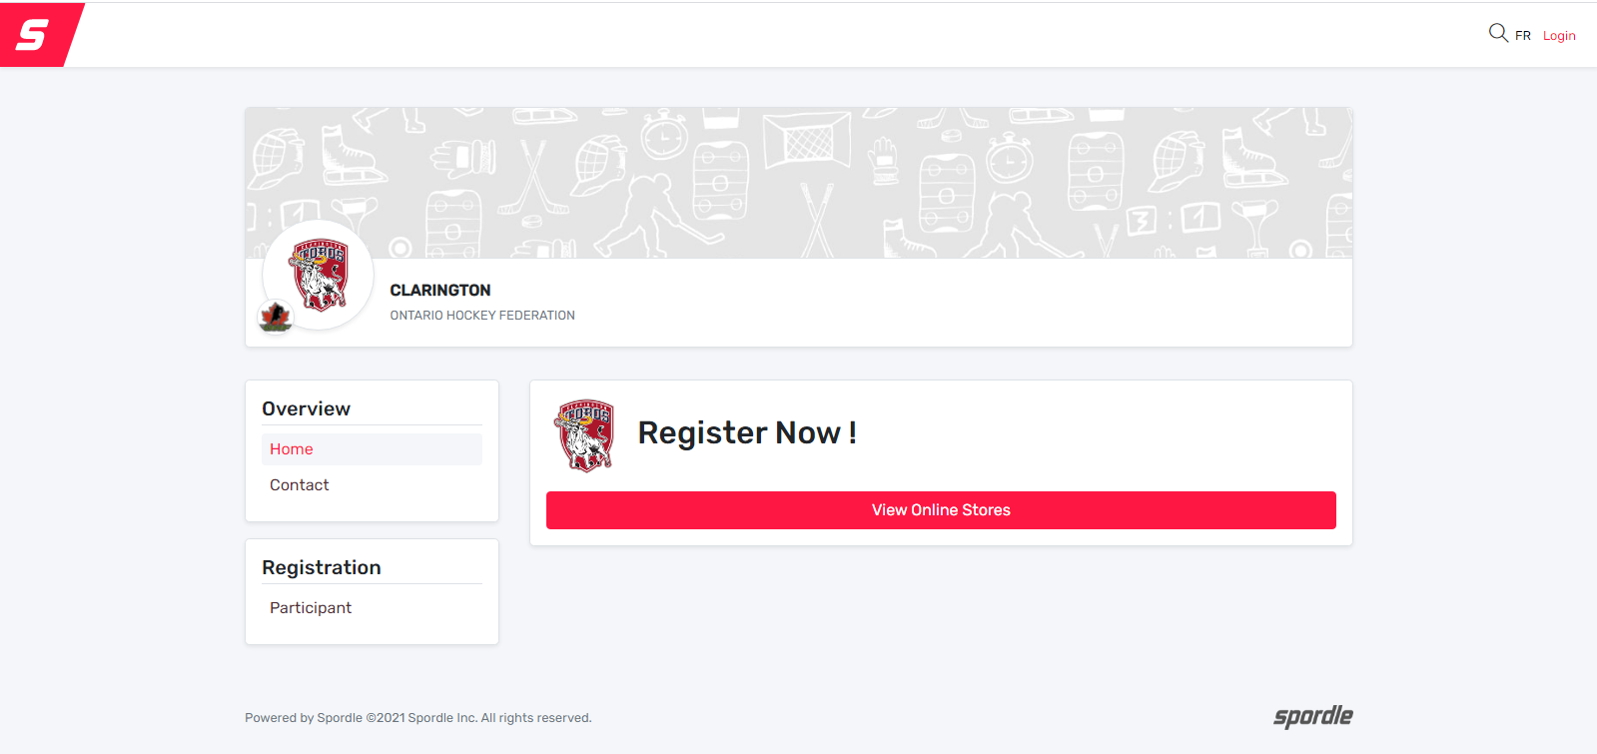
- Click on Register Now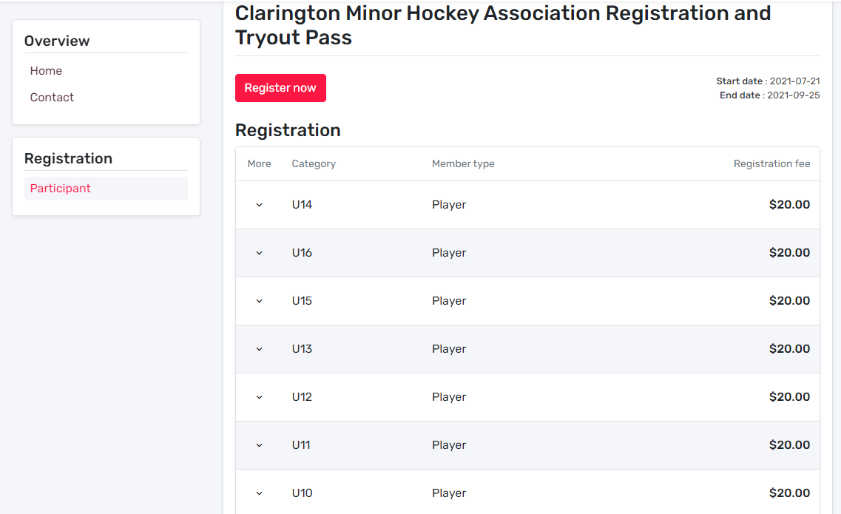
- Click on Start Registration. 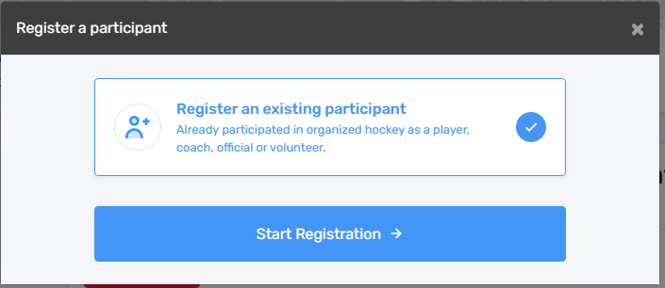
- Select an existing player if recognized or search the HCR website to find your player. 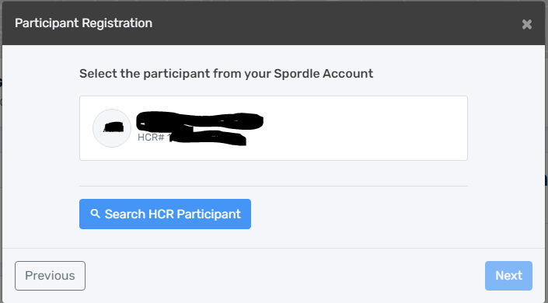 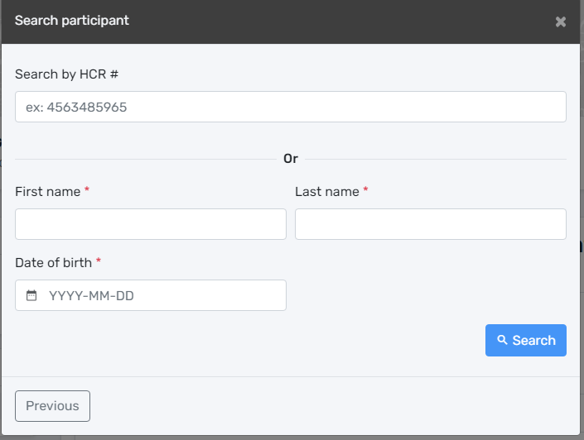
- Select the appropriate division for your player. Then Click Next.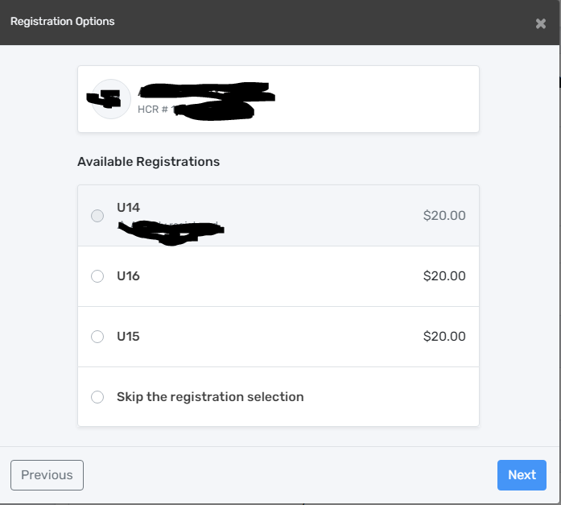

- DO NOT PURCHASE A TRYOUT PASSPORT IF TRYING OUT FOR CZHA AAA TOROS AS CASH IS ACCEPTED AT TRYOUTS. Only select the tryout passport if you are trying out for AA, A, and or AE. If registering multiple players at once you can select the same number of tryout passports. One is needed per player. 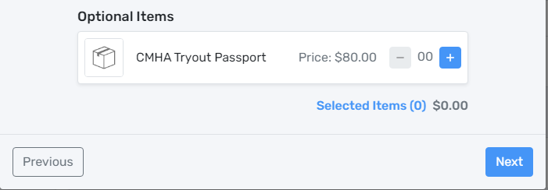
- You will next find 3 waivers that need to be read and agreed to. First from Hockey Canada. 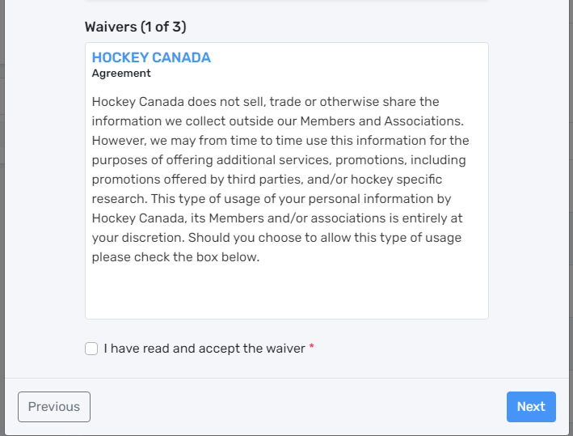 Second from Hockey Canada as well. 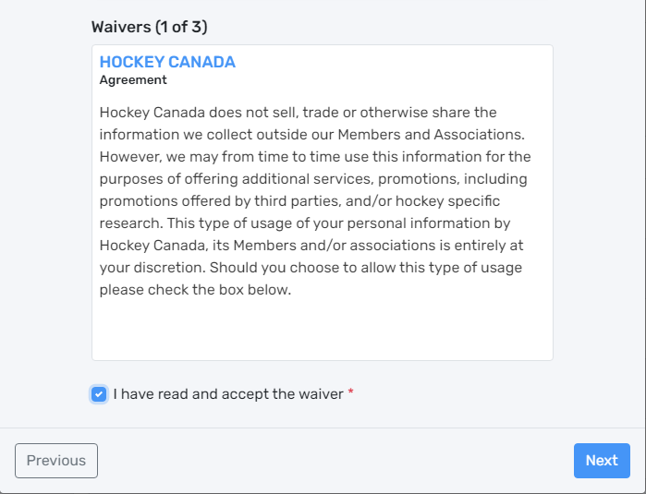

Third is Rowan’s Law from the Ontario Hockey Federation.
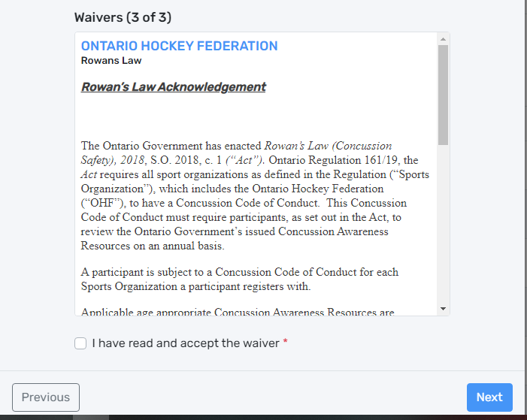
- If you would like to register another participant you can repeat the process above. IF not you can proceed to check out.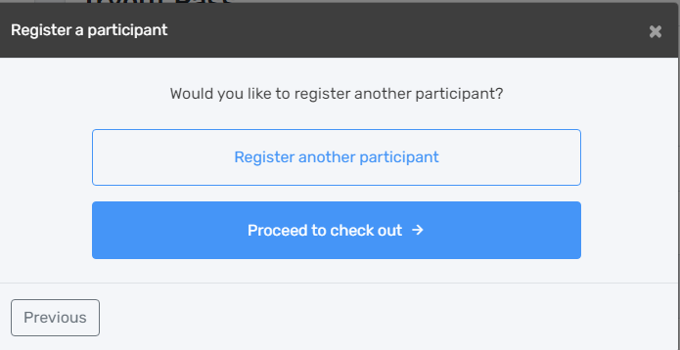
- Next you can review your purchase. Click Next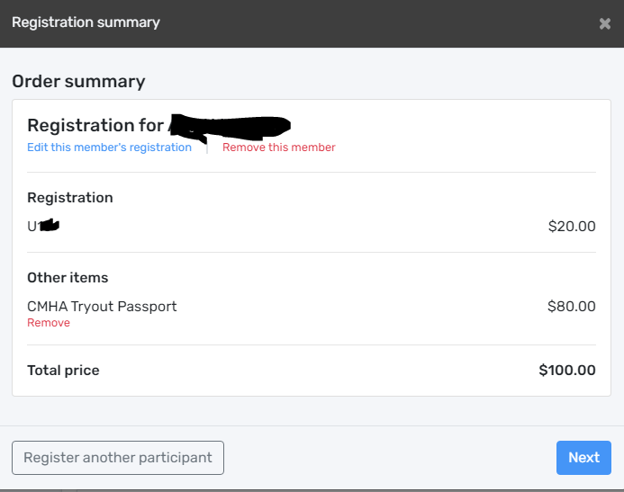
- Next agree to the Terms and Conditions. NOTE: THE $2000 TOROS FEES WILL BE DUE UPON SIGING WITH A TEAM. 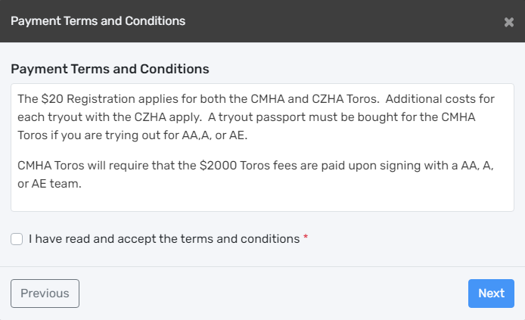
- Select Add new Card and click Next. 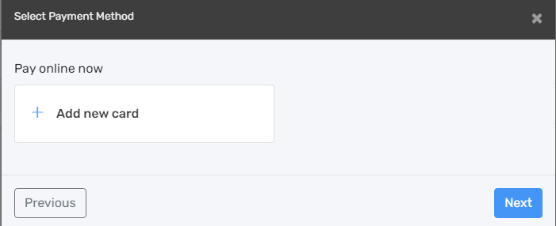
- Fill in your billing and Credit Card information. Click Pay 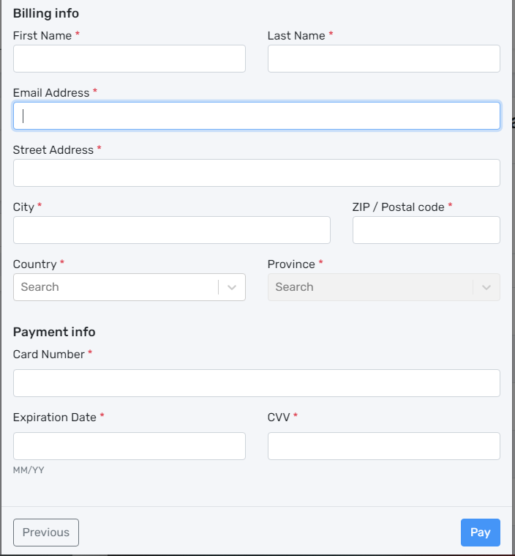
- You will receive an email receipt and a confirmation of your registration. Please Keep this information handy for tryouts in case of any errors.

